**Ideation Phase**

**Empathize & Discover**

|  |  |
| --- | --- |
| Date | 27 June 2025 |
| Team ID | LTVIP2025TMID31912 |
| Project Name | Health AI: Intelligent Healthcare Assistant Using IBM Granite |
| Maximum Marks | 4 Marks |

**Empathy Map Canvas:**

The Empathy Map helps the HealthAI team gain a deep understanding of users — their thoughts, feelings, needs, and pain points — to design a more user-centered AI health assistant. It supports the ideation process by clarifying user goals, behaviors, and barriers.

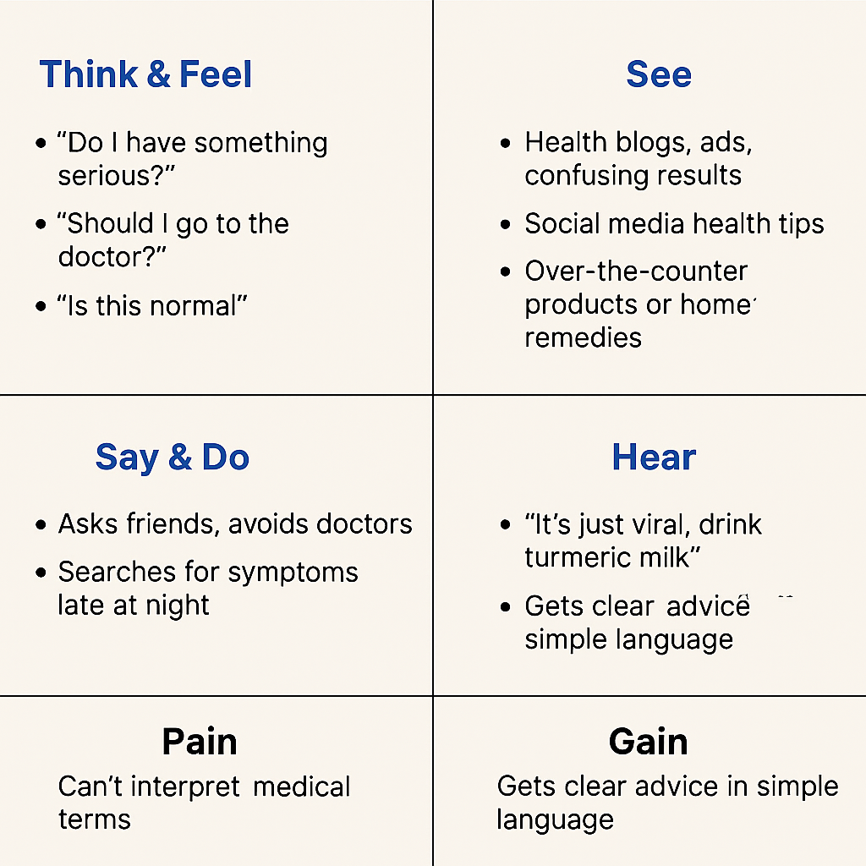

**Example:**

